**CRM APPLICATION FOR JEWEL MANAGEMENT**

**College Name:ST.Joseph’s College For Women**

**College Code:bru4i**

**TEAM ID**:4C26B2DEDBB760E9E2A419F F9B5828F5

**TEAM MEMBERS**:

* **Team Leader:**ASIN FATHIMA.S

**Email**:alonedollqueen@gmail.com

* **Team Member**:ASMAA.S

Email: [asmaasunna10@gmail.com](mailto:asmaasunna10@gmail.com)

* **Team Member**: Hemalatha.P

**Email**: [hemalatha200522@gmail.com](mailto:hemalatha200522@gmail.com)

* **Team Member**:SHANMUGAPRIYA.G

**Email**:Shanmugapriyag1805@gmail.com

**1.INTRODUCTION**

* 1. **Project Overview**

The Jewel Inventory System is a comprehensive software Solution designed to streamline and manage the inventory and sales processes of a jewellery store or a jewellery manufacturer. The system aims to provide an efficient and user-friendly solution to track and control the inventory of various jewellery items, maintain accurate records, and facilitate seamless sales transactions.

* 1. **Purpose**

The main objectives of the CRM Application for Jewel Management is to provide jewelry businesses with an efficient digital platform to manage customer relationships, sales, and inventory in a streamlined way. The system is designed to Centralize Customer data,Enhance Sales & Service, Inventory Management Transaction & Billing.Reports & Insights.Customer Engagement.

**DEVELOPMENT PHASE**

**Creating Developer Account:**

By using this URL- <https://www.salesforce.com/form/developer-signup/?d=pb>

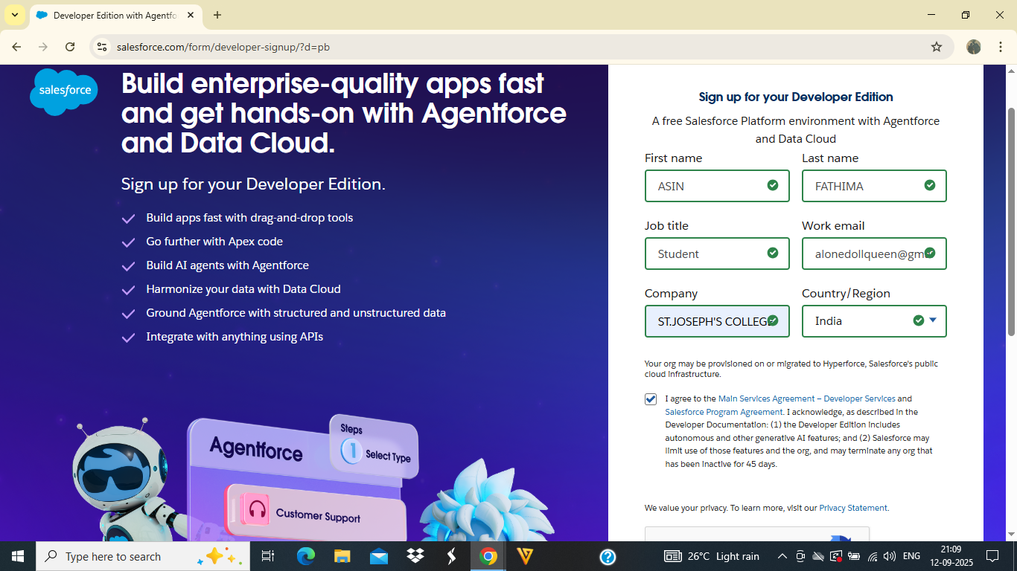

● Created objects: Jewel Customer,Item Object

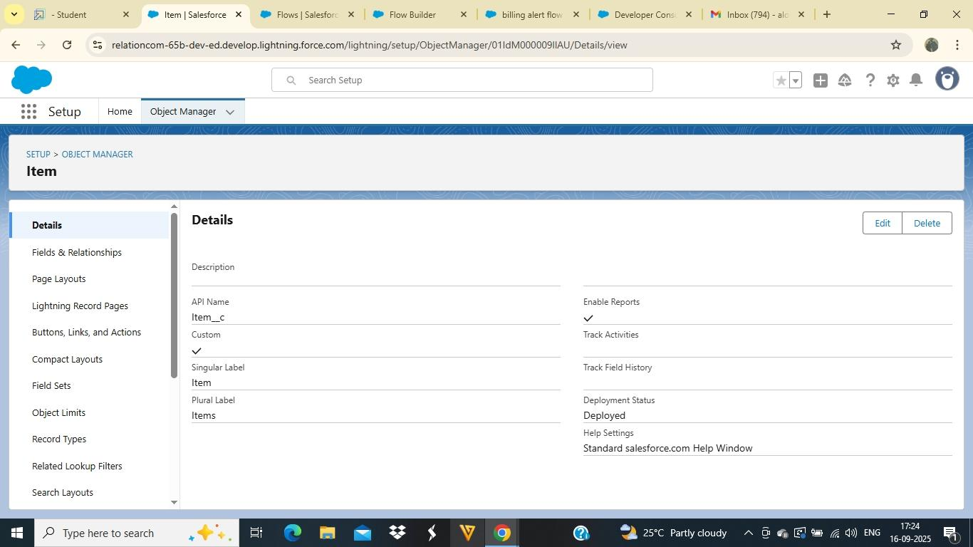

● Create Custom Tabs:

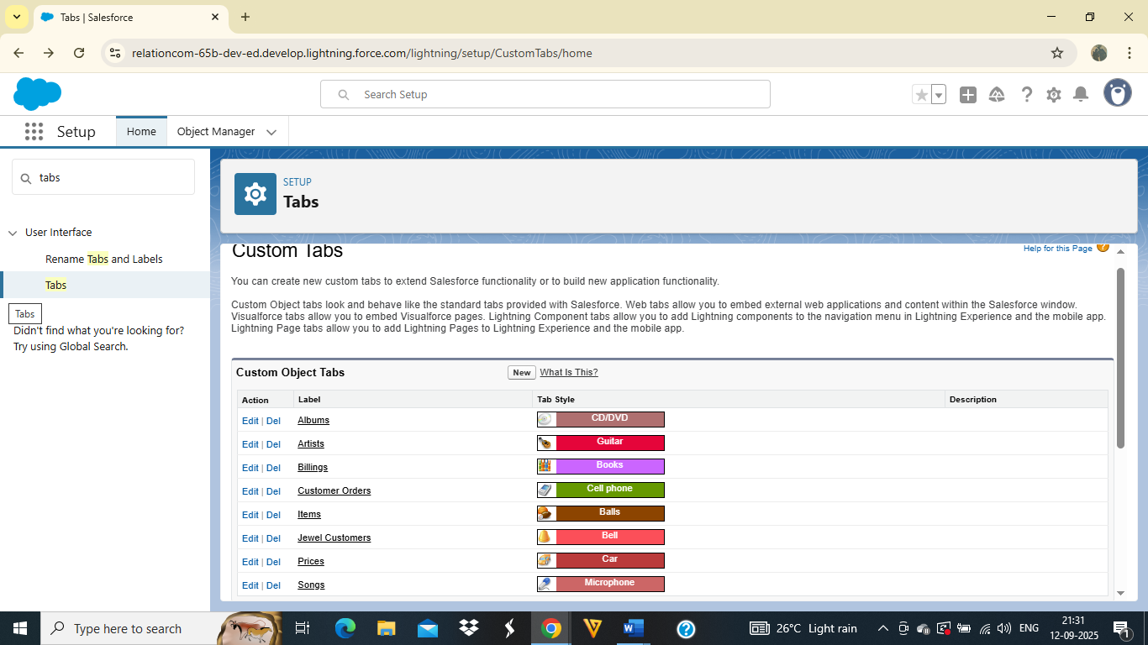

● Developed Lightning App with relevant tabs

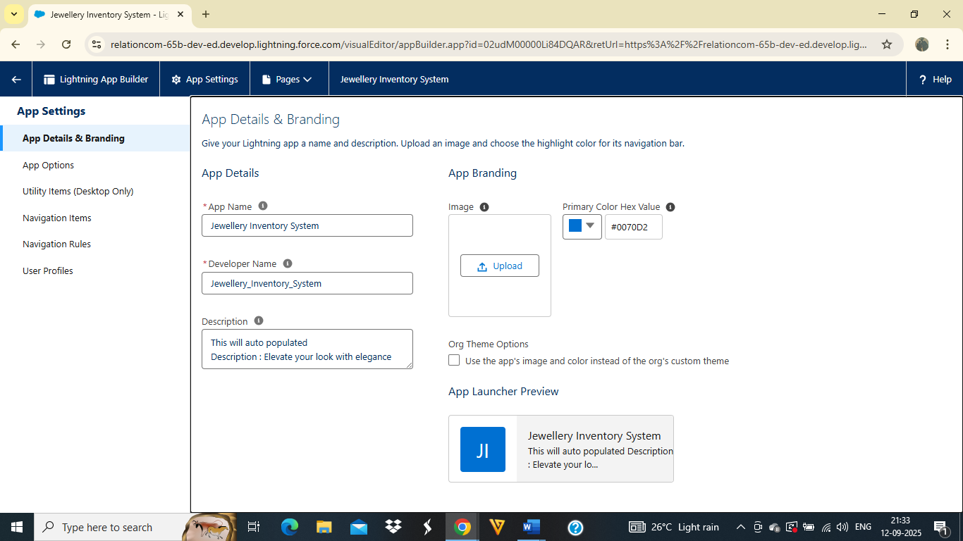

● Configured fields and relationships

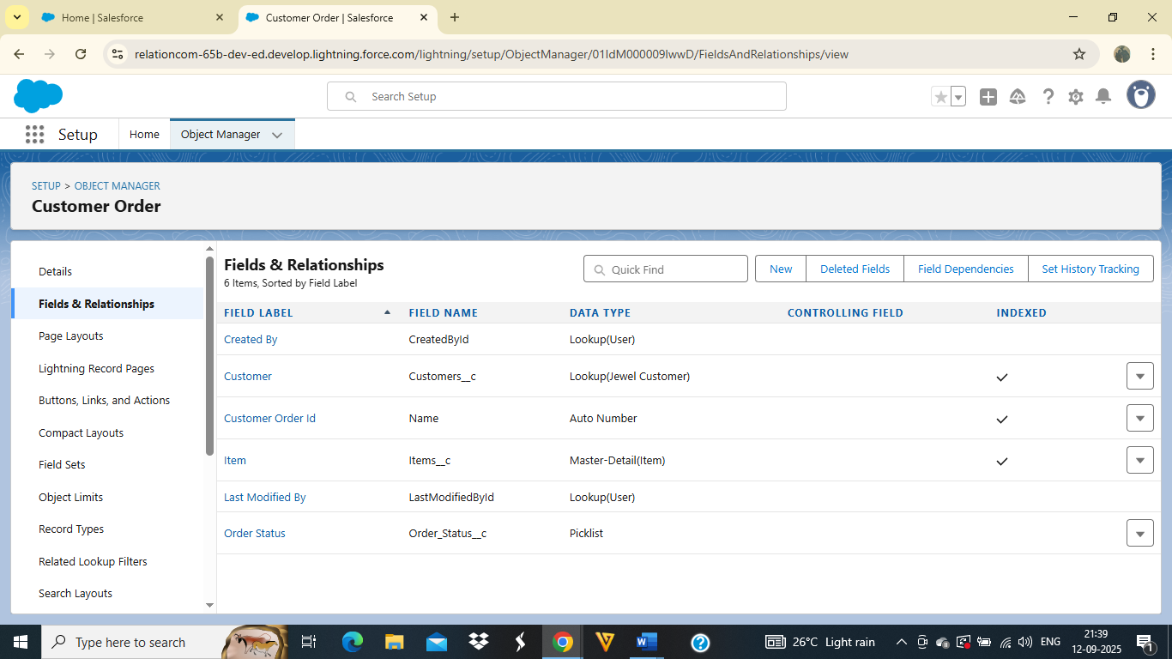

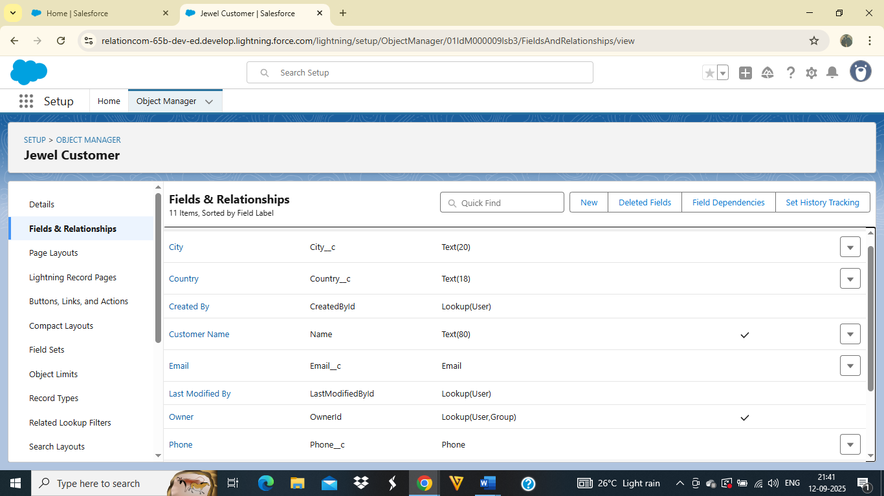

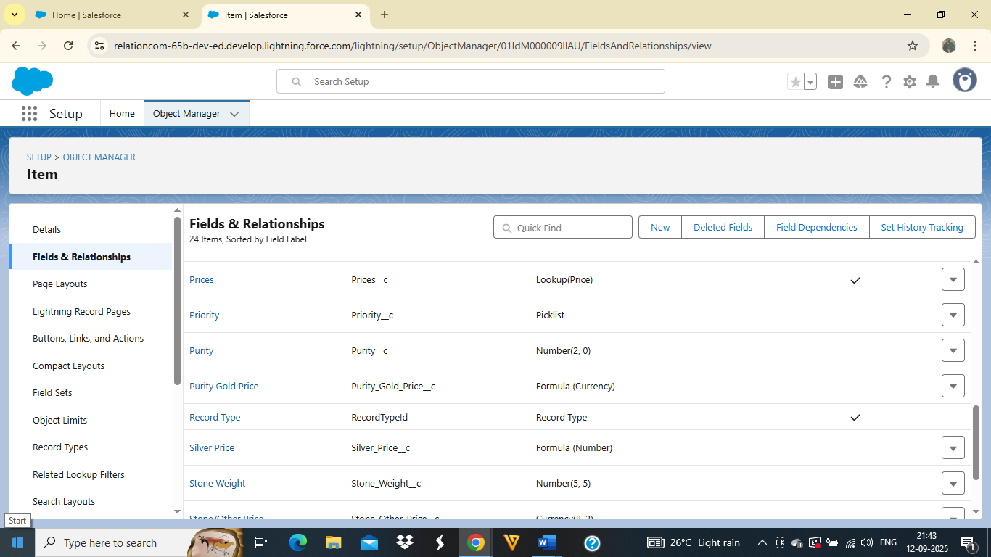

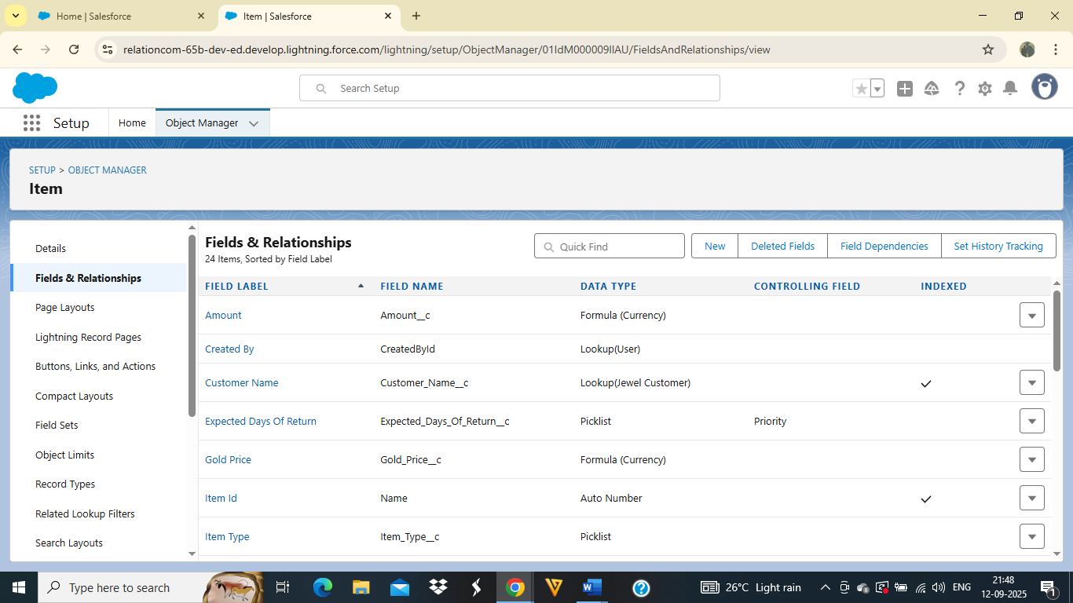

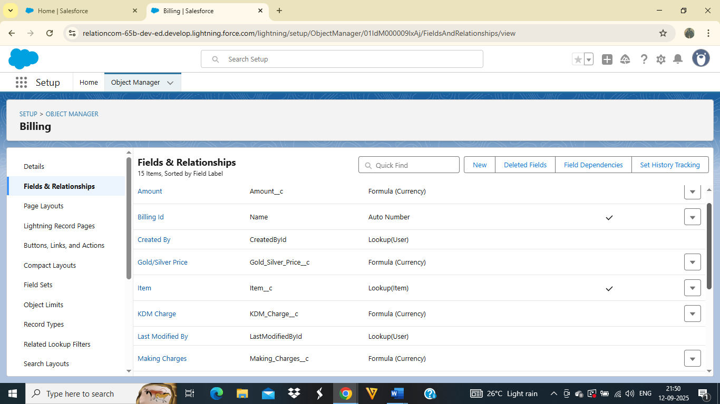

● Profiles

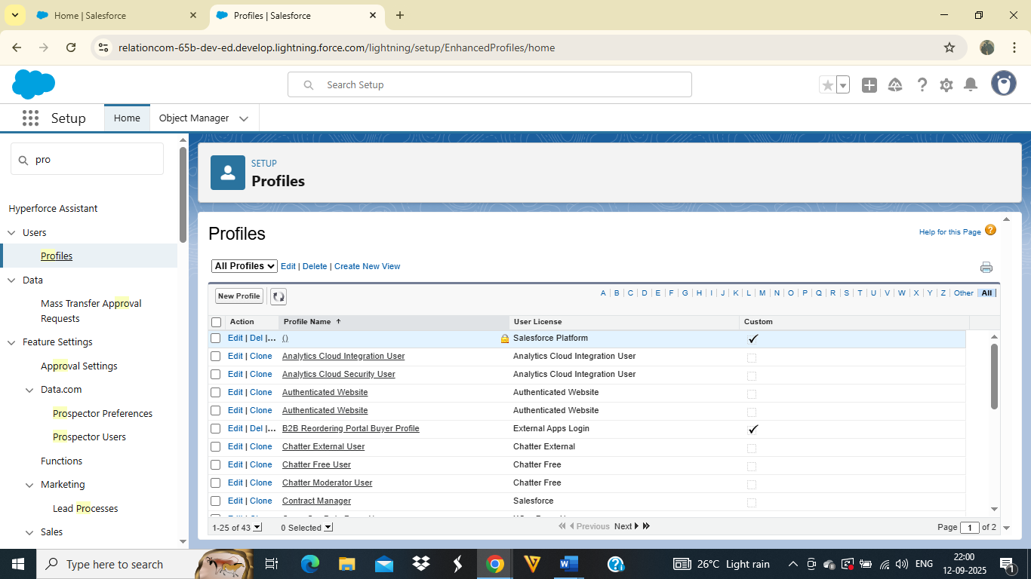

● Roles

● Users

● Page Layouts

● Record Types

● Permission Sets

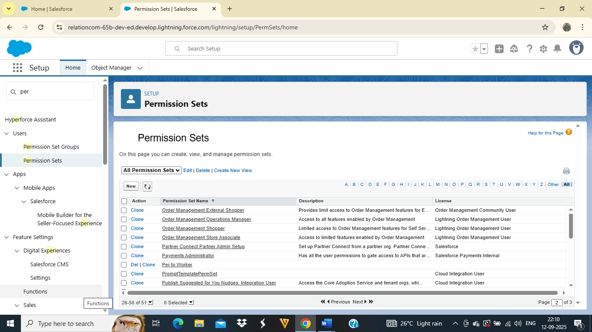

● Apex Trigger

Create an Apex Trigger

Create an Apex Handler class

● User Adoption[Create,View,Delete a Jewel Customer]

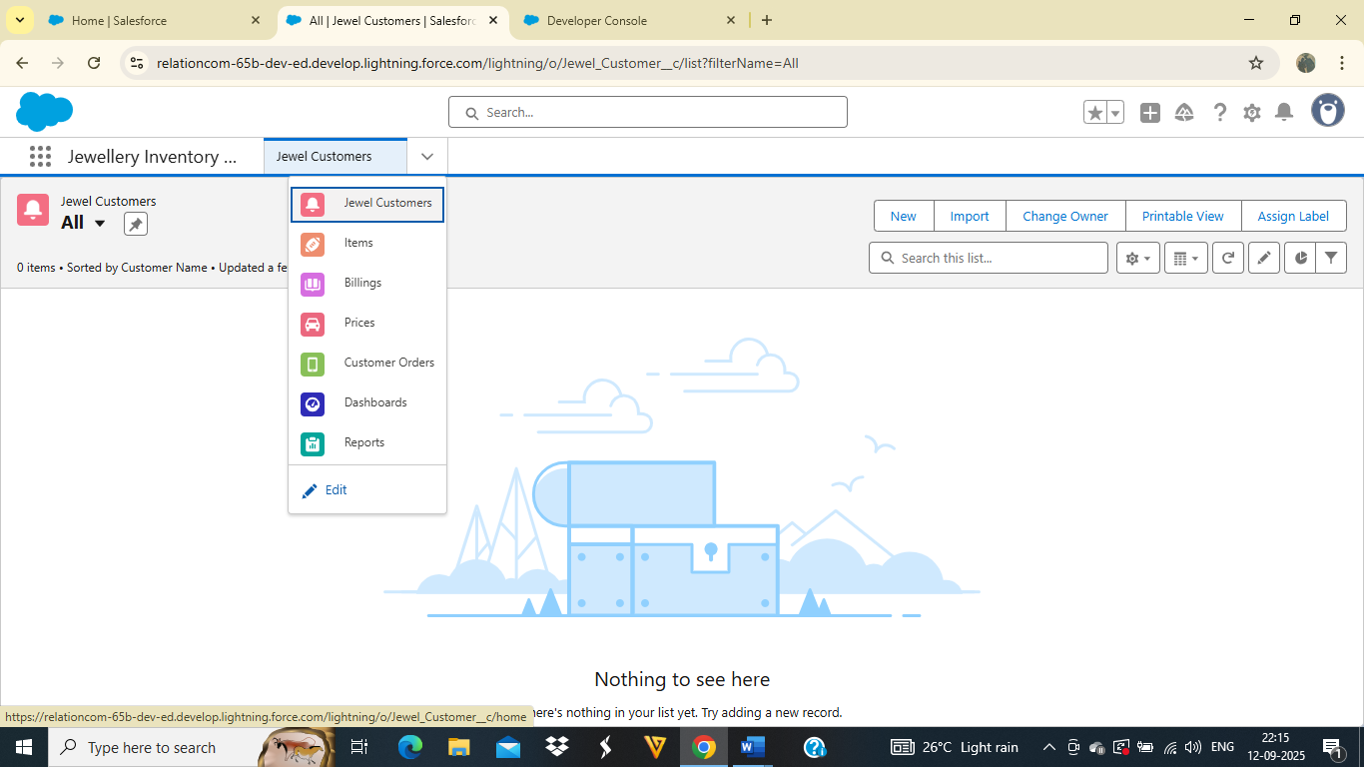

●Reports

●Dashboards

●Flows

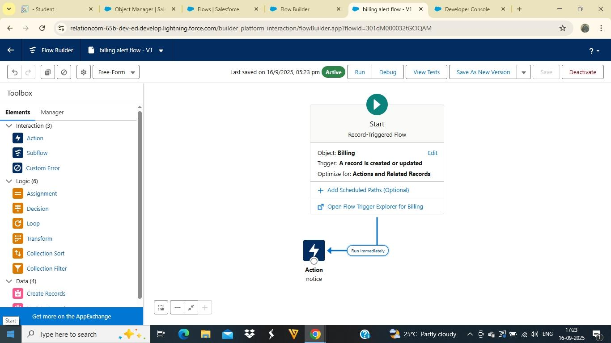

**CONCLUSION**

The CRM Application for Jewel Management serves as an essential tool for modern jewellery businesses by combining inventory control, customer relationship management, and sales automation into one integrated system. It ensures accurate tracking of jewellery items, improves operational efficiency, enhances customer satisfaction, and provides valuable insights through real-time reports and analytics. By reducing manual errors, streamlining sales processes, and maintaining detailed customer records, the system supports better decision-making and long-term business growth.